**4A. Our Team –**profiles of team members

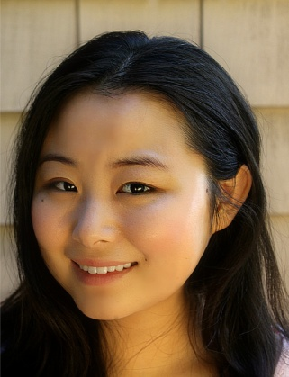

**Jean Guo**

**LinkedIn**

With a background in economics, public health, and policy, Jean is passionate about improving and addressing disparities with regard to equal opportunity. She developed the idea for the project through conversations with the refugee community, which made her realize their lack of access to professional opportunities. She is fluent in English, French, Chinese, and speaks conversational Spanish. In her free time, she sings in a rock a cappella choir in Paris.

**Structure for profile**

<PHOTO>

<ANY SOCIAL MEDIA LINKS: LINKEDIN, GOOGLE PLUS, FB, GITHUB, ETC.>

<SHORT DESCRIPTION>

Description can include a short blurb of what you are passionate about (maybe what drew you to the project), what you are currently doing, your experience in code (if applicable, no worries if not!), and a fun fact.